Assignment-3.R

Zachary

2020-10-31

library(dplyr)

##   
## Attaching package: 'dplyr'

## The following objects are masked from 'package:stats':  
##   
## filter, lag

## The following objects are masked from 'package:base':  
##   
## intersect, setdiff, setequal, union

library(ggplot2)  
  
hist(runif(10))

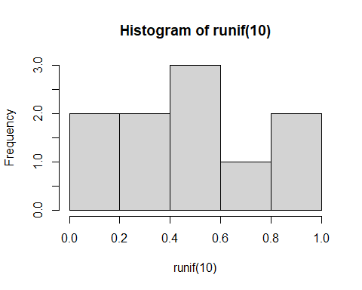

hist(runif(100))

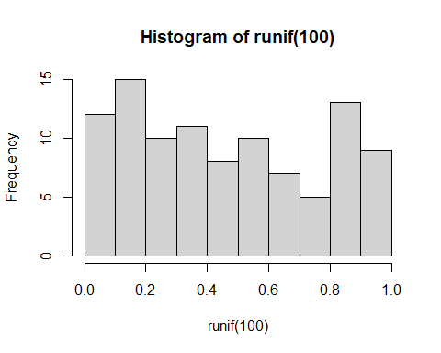

hist(runif(100000))

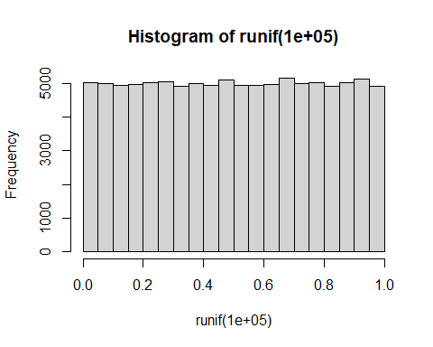

x_var <- (seq(-1, 2, by = 0.01))  
y_var <- dunif(x_var,min=0,max=1)  
y_varr <- bind_cols(y_var,x_var)

## New names:  
## * NA -> ...1  
## * NA -> ...2

plot <- ggplot(data=y_varr, aes(x=...2,y=...1)) + geom_point() +   
 labs(y = "Probability", x = "Seq of numbers") +   
 geom_segment(aes(x=0.37629,y=0,xend=0.37629,yend=1.0), color = "blue", size=1.5)  
  
vote <- sample(c(1,0),100,replace=TRUE,prob=c(0.7,0.3))  
hist(vote, main="Histogram from Sample function", xlab = "Voted")

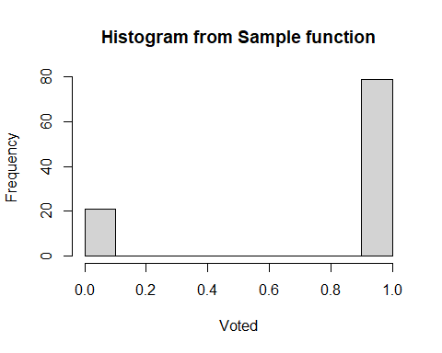

total_vote <- sum(vote==1)  
  
vote_bi <- rbinom(100, 1, 0.7)  
hist(vote_bi, main="Histogram from rbinom function", xlab = "Voted")

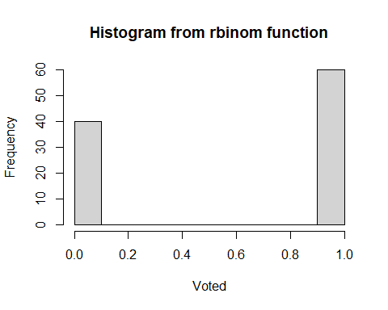

total_vote_bi <- sum(vote_bi==1)  
cat("People who voted: ", total_vote)

## People who voted: 79

cat("People who voted (rbinom): ", total_vote_bi)

## People who voted (rbinom): 60

rbinom(1,100,0.7)

## [1] 68

rbinom(100,1,0.7)

## [1] 1 0 1 1 0 0 0 0 0 1 1 1 1 1 1 1 1 0 1 1 1 0 1 0 1 1 0 1 0 0 1 1 1 0 1 1 1  
## [38] 0 0 1 1 1 1 0 0 1 1 0 1 1 1 1 1 1 1 1 0 1 1 0 1 0 1 1 0 1 1 1 1 1 1 1 0 1  
## [75] 1 1 1 1 1 1 1 0 1 0 1 1 1 0 1 0 1 1 0 0 1 1 1 1 1 1

prob_pand <- dpois(4,1)  
cat("Probability of 4 Pandemics in a decade: ", prob_pand)

## Probability of 4 Pandemics in a decade: 0.01532831

plot(dpois(seq(0,20,1),1))

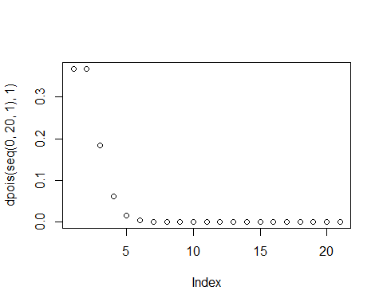

for (i in c(3,7,10)){  
 plot(dpois(seq(0,20,1),i))  
}

